SPRINT -1

|  |  |
| --- | --- |
| Date | 15 November 2022 |
| Team ID | PNT2022TMID48655 |
| Project Name | Gas leakage monitoring and alerting system for industries |

# SIMULATION :

#include <LiquidCrystal.h> #include "DHTesp.h"

#define BUZZER_PIN 19 // define type of sensor DHT 11 const int DHT_PIN = 25;

DHTesp dhtSensor;

LiquidCrystal lcd(4,15,5,18,21,22); int ThreshHold = 60;

void setup() {

Serial.begin(9600); dhtSensor.setup(DHT_PIN, DHTesp::DHT22); lcd.begin(16,2);

pinMode(BUZZER_PIN, OUTPUT);

}

void loop() { delay(2000);

TempAndHumidity data = dhtSensor.getTempAndHumidity(); Serial.println("Temperature: " + String(data.temperature, 2) + "°C"); Serial.println("Humidity: " + String(data.humidity, 1) + "%");

int gassensor=random(0,100);

Serial.print(F("Gas Concentration: "));

Serial.println(gassensor);

if (gassensor>ThreshHold)

{

Serial.println(F("GAS LEAKED ALERT!"));

Serial.println(); lcd.clear();

lcd.print ("GAS LEAKAGE :("); tone(BUZZER_PIN,31);

delay (1000); lcd.clear();

lcd.print ("ALERT!!!"); delay(1000); noTone(BUZZER_PIN);

}

else

{

Serial.println(F("SAFE!")); Serial.println();

lcd.clear();

lcd.print ("ALL GOOD :)"); delay(1000);

lcd.clear();

lcd.print ("SAFE!"); delay(1000);

}

}

# CIRCUIT DIAGRAM :

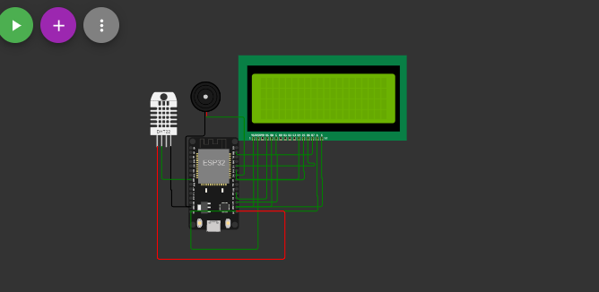

**RESULT :**

1. **OUTPUT IN NORMAL MODE**

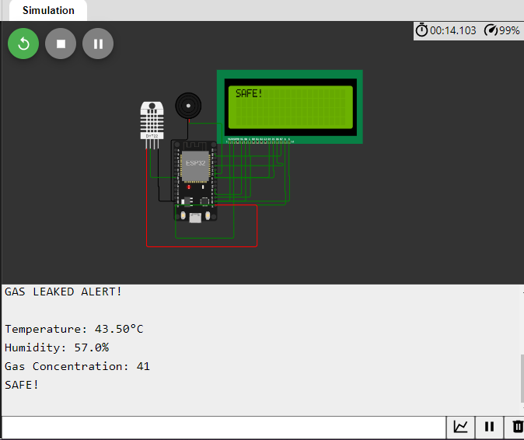

**2. Output in Alert mode:  
  
